**Model Question**

**First terminal exam**

Class 3 Subject Maths Time 2 hr F.M. 50

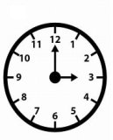1. Write the time shown by each clock. [2x1=2]

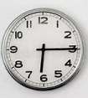a) b)

2. Write am or pm in the blanks. [2x1=2]

a) 8:30 in the evening it is 8:30…..

b) 6 o’clock in the morning. It is 6:00 …….

3. Write the place and place value of underlined digits [2x2=4]

a) 4660 b) 5709

4. Write the number 6453 in the place value table. [2]

|  |  |  |  |
| --- | --- | --- | --- |
| thousands | hundreds | tens | ones |
|  |  |  |  |

5. Compare the following numbers by using <, > or = [3x1=3]

a) 482 [ ] 482 b) 700+30+4 [ ] 764 c) 589[ ] 498

6. Write the number names of following numbers. [2x2=4]

a) 5670 b)9807

7. Write in numbers. **[2x2=4]**

a) four thousand three hundred ninety six .

b) six thousand eight hundred seventy nine.

8. Write the number names of following numbers in Devnagari number system. **[2x1=2]**

a) #$ b) (&

9. Write in devnagari digits. **[2x1=2]**

a) 367 b) 9856

10.Write in ascending order. [2]

4567, 4867, 4267, 4267, 4487

11. Write in descending order. [2]

7834, 7734, 7534, 7934,7634

12. Write in expanded form [2x1=2]

a) 7632

b) 5609

13. Write in short form.[2x1=2]

a) 5000+600+20+4

b) 9000+000+600+00+9

14. Complete the numbers.[2]

768,769 , ……. , ……. , ……… , ………. ,774

15. Add [2x2=4]

a) 4 6 b) 3 6 7

+3 7 +3 4 4

16. Subtract: [2x2=4]

a) 4 6 b) 3 6 7

-2 4 -1 5 5

17. Study the following calendar and answer the following questions.[2x1=2]

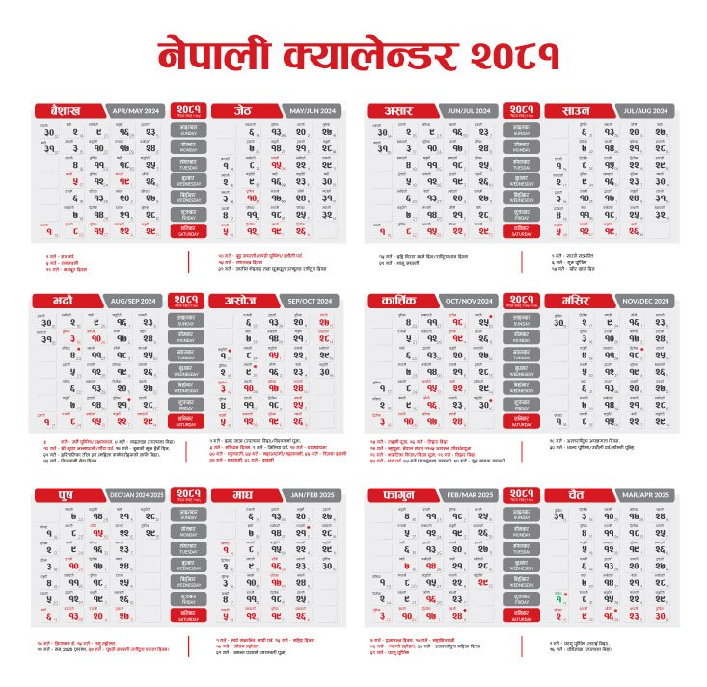

a) How many days are there in this month?

b) How many Saturdays are there in this month?

**Word problems.** **[2x2=4]**

18. A box contains 60 marbles and another box contains 50 marbles . How many marbles are there altogether?

19. You buy 70 chocolates on your birthday , and you gave 39 chocolates to your friends . how many chocolates are left with you?

**[The End]**

**Model Question**

**Second terminal exam**

Class 3 Subject Maths Time 2 hr F.M. 50

1. Write the place and place value of 7 in 4**7**8090 [2]

2. Compare the following numbers by using <, > or = [3x1=3]

a) 4682 [ ] 4682 b) 7000+300+40+9 [ ] 7649 c) 5589[ ] 5498

3. Write the number names of following numbers. [2x2=4]

a) 56370 b)19807

4. 7. Write in numbers. **[2x2=4]**

a) forty-six thousand three hundred ninety six .

b) sixty-seven thousand eight hundred seventy nine.

5. 8. Write the number names of following numbers in Devnagari number system. **[2x1=2]**

a)$#$ b) %(&)

6. Write in Devnagari digits.[2x1=2]

a) 35672 b) 98760

7. Write in Roman number system[2x1=2]

a) 5 b) 20

8. Write in expanded form.[2x1=2]

a) 67891 b) 43276

9. Write in short form[2x1=2]

a) 50000+6000+900+20+7

b) 20000+7000+000+50+1

10. Write in ascending order.[2]

7834, 7734, 7534, 7934,7634

11. Write in Descending order.[2]

4567, 4867, 4267, 4267, 4487

12. Write even and odd numbers between 20 and 30.[2]

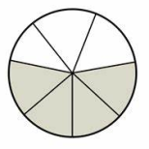13. Write the fraction of shaded parts.[2x1=2]

a) b)

Fraction of shaded parts= Fraction of shaded parts=

14. Add or subtract the following like fraction.[2x1=2]

a) $\frac{5}{11}+\frac{3}{11}$ b) $\frac{8}{15}-\frac{4}{15}$

15.Write in decimal [2x1=2]

a) =…….. b) = ………

15. Add [2x2=4]

a) 4 4 6 b) 8 3 6 7

+3 5 7 +3 6 4 4

16. Subtract: [2x2=4]

a) 4 6 5 b) 6 3 6 7

-2 4 4 -1 9 5 5

17. Study the following calendar and answer the following questions.[2x1=2]

a) How many Sundays are there in this month?

b) Which is the last day of Asar?

18 Word problems.

a) Saurav has 1281 baseball cards. Ankita has 1535. If Saurav and Ankita combine their baseball cards, how many cards will there be?[2]

b) There are 3561 students in a school. Among them ,1681 are girls. How many boys are there in the school?[2]

**[The End]**

**Model Question**

**Third Terminal exam**

Class 3 Subject Maths Time 2 hr F.M. 50

1. Write the place value of 9 in **9**6786 . [1]
2. Write the number name of 58921. [1]
3. Write in numeral [1]

Sixty-four thousand three hundred seventeen.

1. Write the Devnagari number name of following [2x1=2]
2. @%^$# b) (()((
3. Write the following number in Devnagari digits . [2x1=2]
4. 2399 b) 76340
5. Compare these numbers using < , > or = [3]

a) 4682 [ ] 4682 b) 7000+300+40+9 [ ] 7649 c) 5589[ ] 5498

1. Write in expanded form of 45698. [1]
2. Write in short form of : 30000+9000+700+300+50+7 [1]
3. Write in ascending order. [2]

7834, 7734, 7534, 7934,7634

1. Write in descending order. [2]

7834, 7734, 7534, 7934,7634

1. Write even and odd numbers between 80 and 90. [2]
2. Write the fraction of shaded parts.[1]

Fraction of shaded parts=

1. Add or subtract of these like fractions:[1x1=1]

a)

14. Write in decimal [2x1=1]

a) = ………

15. Add a) 5 6 7 8 [2]

+4 5 6 7

16. Subtract :a) 5 6 7 8 [2]

-2 5 6 7

17. Multiply: a) 578 b) 235 [2x2=4]

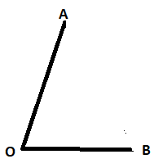 - x 7x1 2

18. Divide : a) 482 b) 1255 [2x2=4]

19. Draw the line segment of 4 cm. [2]

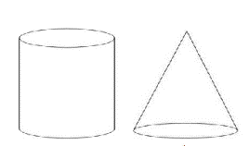20. Write the vertex and arms of the following angle. [2]

21. Write the name of solid objects.[2x1=2]

22. Convert the following lengths into

as indicated.[2x1=2]

1. 5m=……..cm b) 300 cm =……..m

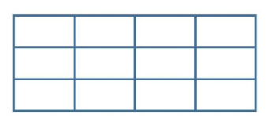23. Find the area of given rectangle [1 square box = 1 m2] [1]

Area of rectangle = …. sq cm

24. A cow gives 4 l 750 ml in the morning and

4l 200 ml in the evening. How much milk does

it give each day?[2]

25. Class three students visited the zoo. They counted the following animals in the zoo. The numbers of animals are presented in the following bar graph.

1. How many monkeys are there?[1]
2. which animals are in least number?[1]

26. Sarita spent Rs. 48370 on Monday and Rs.6750 on Tuesday. How much did she spend ?[2]

b) There are 6580 apples in a store, 3351 of them are rotten. How many apples are good?[2]

**[The End]**

**Model Question**

**Final Examination 2081**

Class 3 Subject Maths Time 2 hr F.M. 50

1. 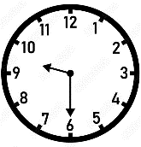Write the number name of 67921. [1]
2. Write in numeral [1]

Sixty-four thousand nine hundred seventeen.

1. a) Write the time shown by the given clock.[1]
2. how many days are there in 1 month?[1]
3. Compare these numbers using < , > or = [3]

a) 4682 [ ] 4682 b) 7000+300+40+9 [ ] 7649 c) 5589[ ] 5498

1. Write even and odd numbers between 50 and 60. [2]
2. Write the number 3908 in Devnagari numbers [1]
3. Write in expanded form of 56329.[1]
4. Write in short form of : 60000+9000+500+300+20+3 [1]
5. Write in ascending order. [2]

7834, 7734, 7534, 7934,7634

1. Write in descending order. [2]

7834, 7734, 7534, 7934,7634

1. Write the fraction of shaded parts.[1]

Fraction of shaded parts=……..

1. Write in decimals of =…….. [1]

13. Add 5678 [2]

+4567

14. Subtract : 5078 [2]

- 2567

15. Multiply : a) 318 b) 235 [2x2=4]

- x 4x 2 5

16. Divide : a) 684 b) 3465 [2x2=4]

17. Draw the line segment of 6 cm.[2]

18. Draw the angle with the help of scale. [2]

19. Write the name of following solid objects. [1]

20. Convert the following lengts into as indicated.[2x1=2]

a) 5km= ……..m b) 600cm = ………m

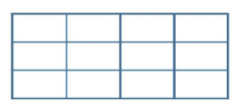21. Find the area of given rectangle [1 square box = 1 m2][1]

Area of rectangle = …. sq cm

22. Add or subtract [2x1=2]

a) 5y + 7y =………. b) 9sm- 3m = …………

23. Convert the following into as indicated:[2x1=2]

a) 5 l = ……. ml b) 6000 ml = …… l

24. Class three students visited the zoo. They counted the following animals in the zoo. The numbers of animals are presented in the following bar graph. [2x1=2]

1. How many tigers are there?
2. which animal is most populated in the zoo?

25. Ramesh is 23 kg 400g and Suhana is 24 kg 325 g. What is the total

weight of them.[2]

26. Word problems. [4x2=8]

. a) Unika spent Rs. 58370 on Monday and Rs.6850 on Tuesday. How

much did she spend altogether?

1. There are 6580 mangoes in a store, 3351 of them are rotten. How many mangoes are good?
2. If a worker earns Rs. 525 in 1 day. How much money does he spend in 7 days?
3. If the cost of 8 packets of biscuits is Rs. 96. What is the cost of 1 packet of biscuit?

**[The End]**